**Tutotrial: Hyperledger Fabric**

You **MUST** visit the Hyperledger Docs. (Below link)

<https://hyperledger-fabric.readthedocs.io/en/release-2.5/test_network.html>

1. Open Docker Desktop. (**Always** before working on Hyperledger Fabric).

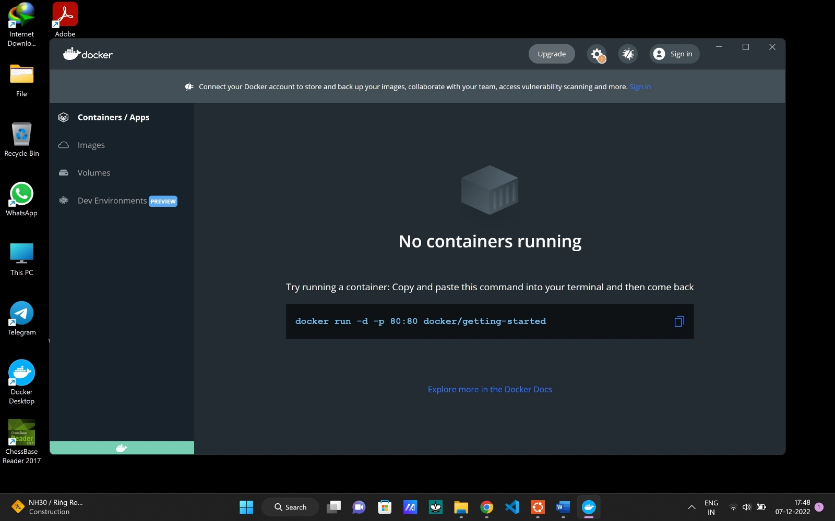

1. Now open ubuntu as administrator and run the below command to go in fabric-sample folder.

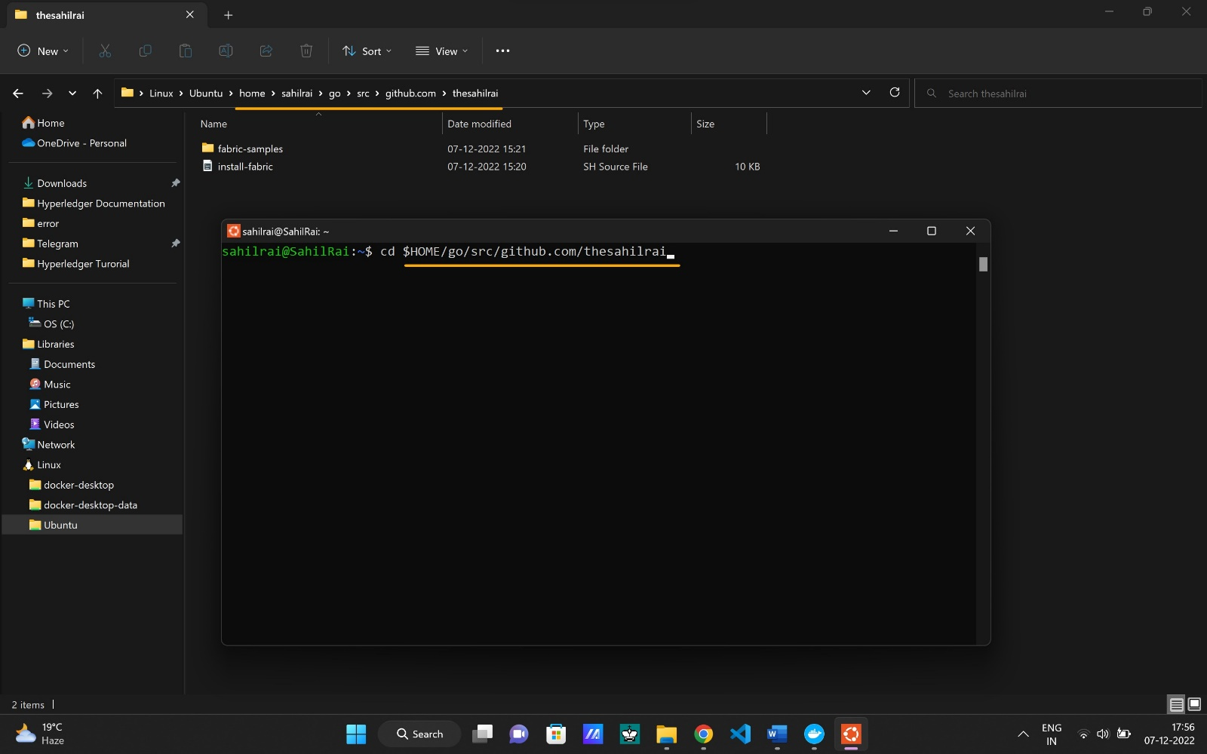

1. Go to the fabric-samples/test-network
   1. cd fabric-samples/test-network

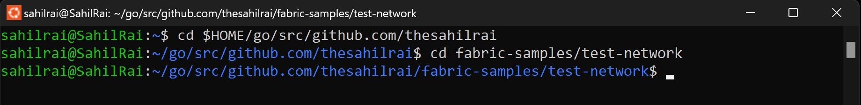

1. Run the following command to remove any containers or artifacts from any previous runs.
   1. ./network.sh down

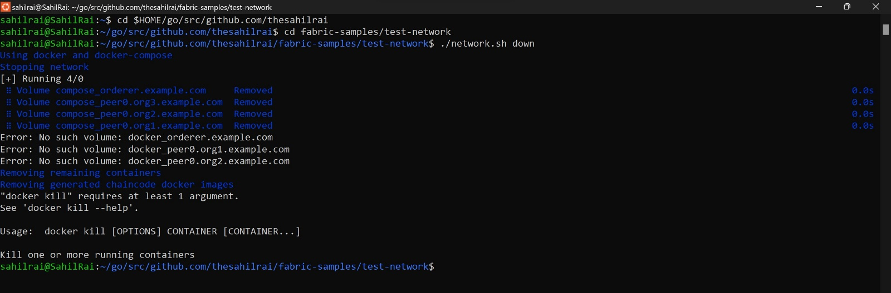

1. You can then bring up the network.
   1. ./network.sh up

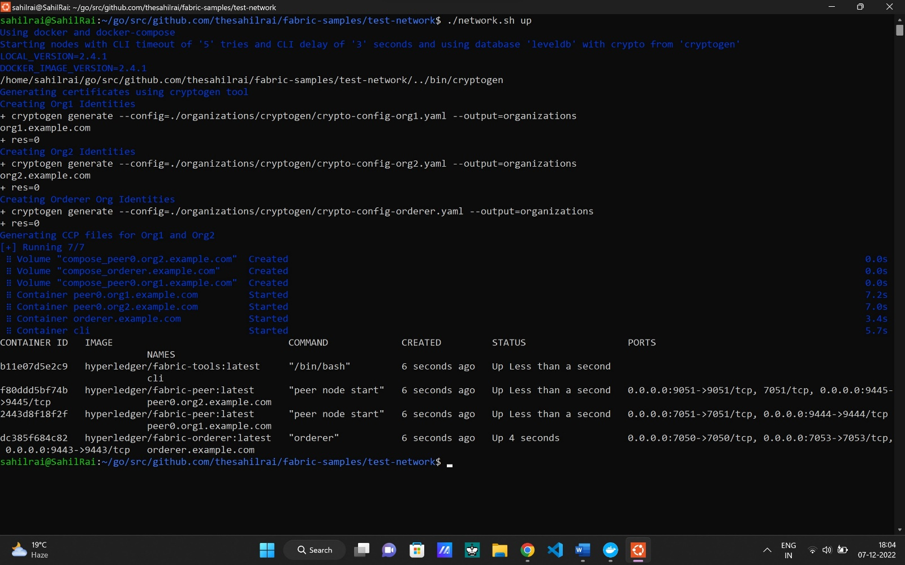

Now you can also see in docker desktop.

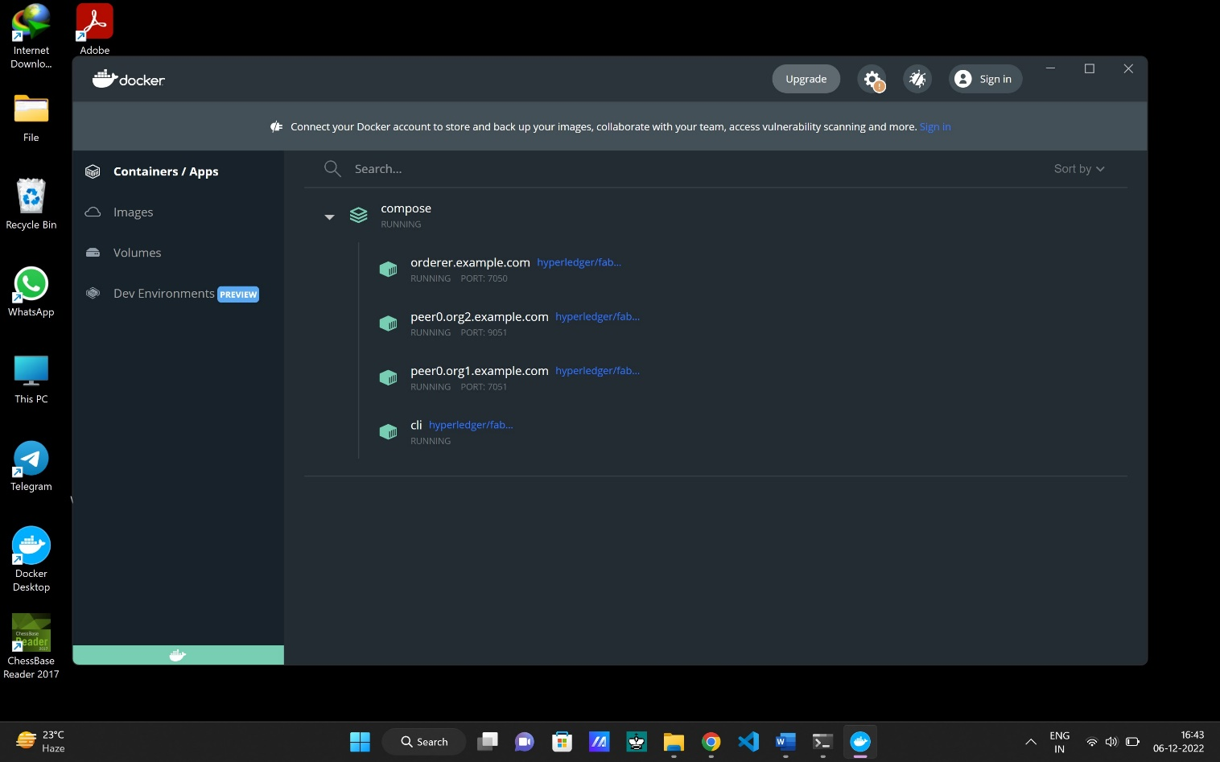

Here you can see that there is two organization i.e. org1 and org2 and the one orderer.

1. To check how many containers are running.
   1. docker ps -a

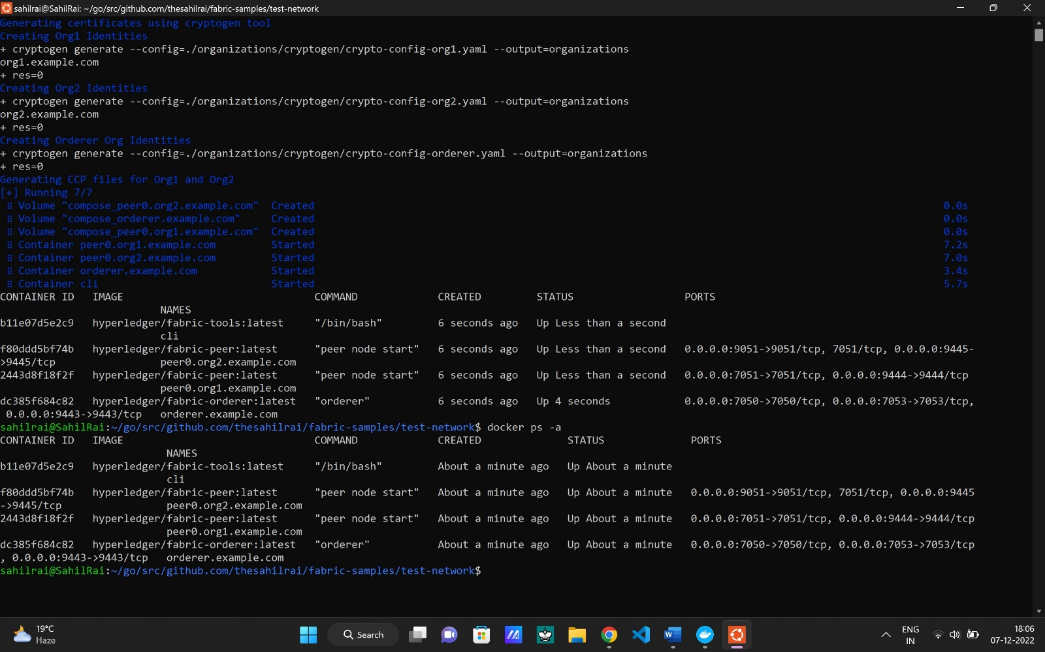

1. To channel between org1 and org2. (Default name is ‘ mychannel ’).
   1. ./network.sh createChannel

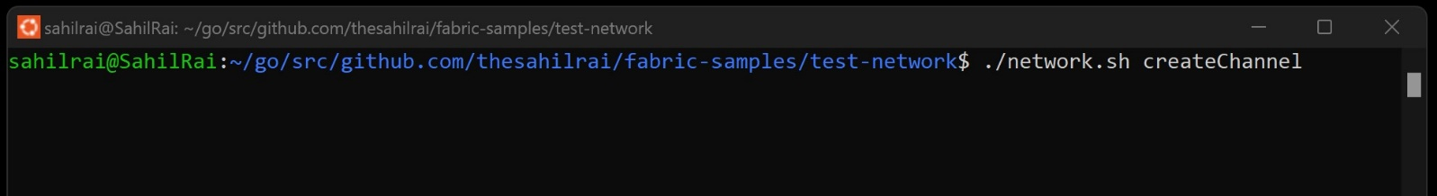

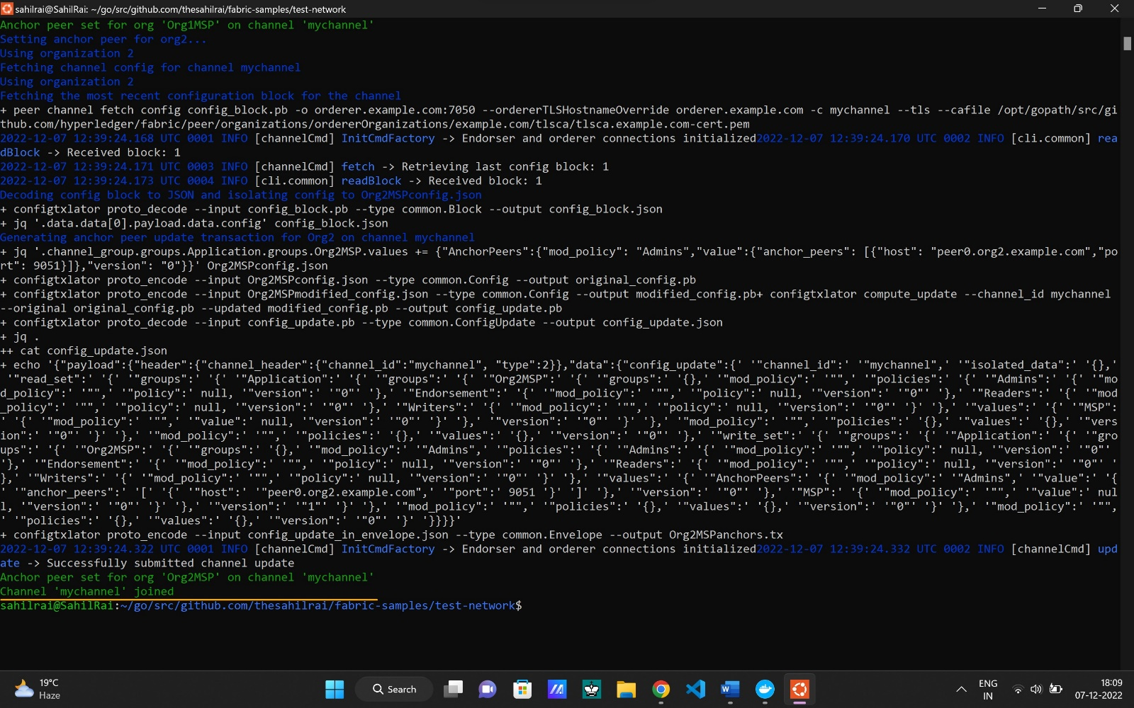

As you see the 2nd last line i.e. Channel ‘mychannel’ joined.

1. You can deploy a chaincode on the channel using the following command.

( chaincode is smart contract and ‘deployCC’ means deploy chaincode which is written in go ) .

* 1. ./network.sh deployCC -ccn basic -ccp ../asset-transfer-basic/chaincode-go -ccl go

May be it through error like this.

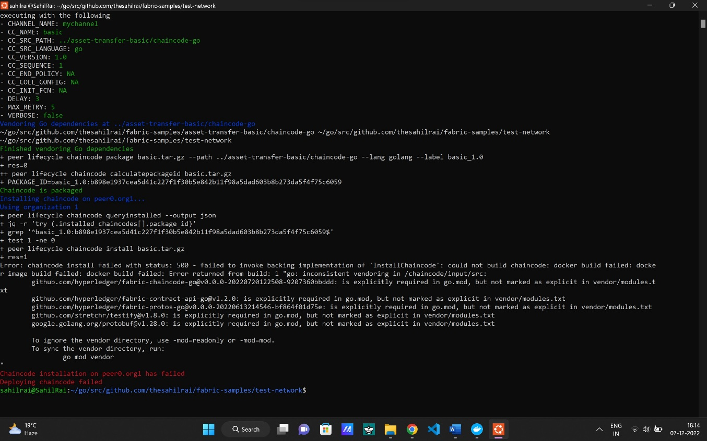

To solve this go to the ” fabric-samples/asset-transfer-basic/chaincode-go ”.

And open it in vs code.

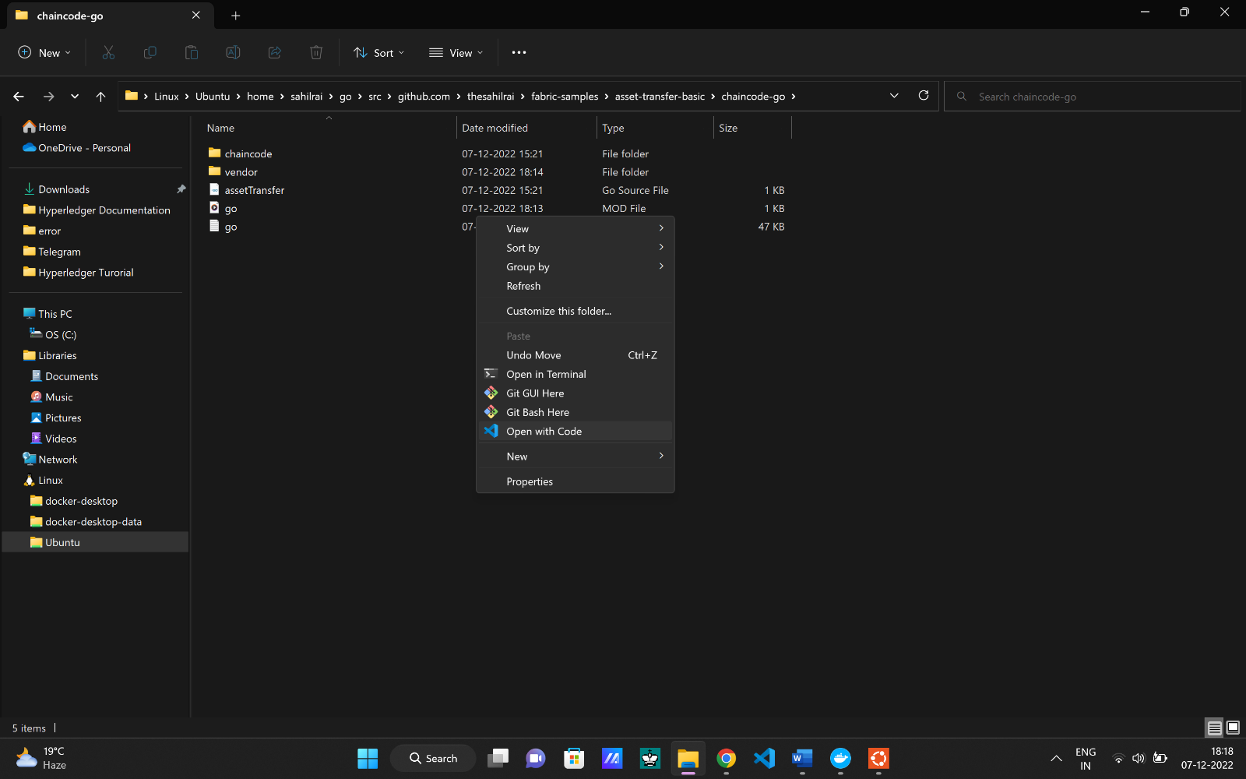

Now open go.mod file in vs code.

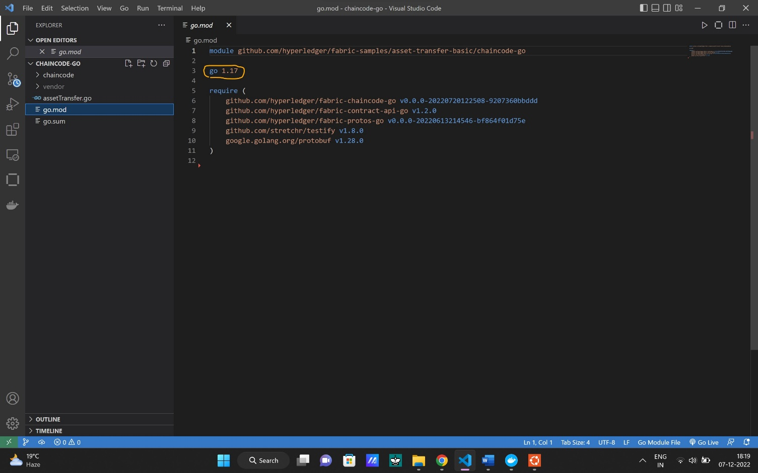

And change go1.17 to go.13 and save it.

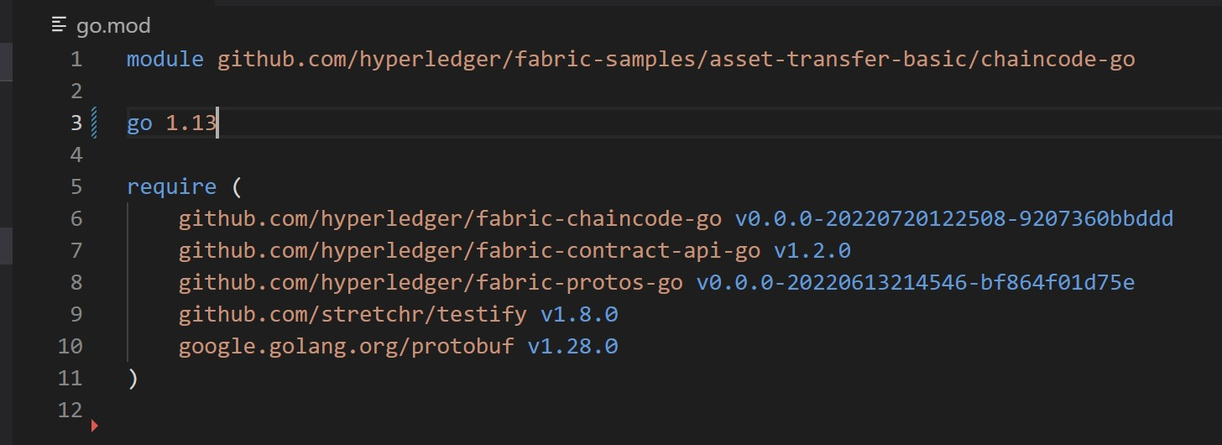

Now run the command to deploy chaincode.

1. ./network.sh deployCC -ccn basic -ccp ../asset-transfer-basic/chaincode-go -ccl go

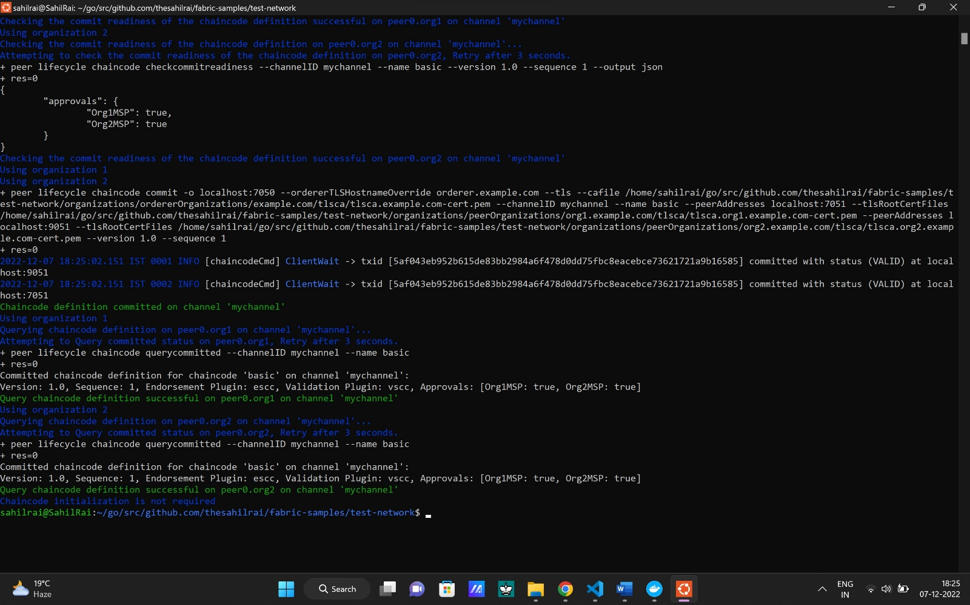

Now channel is deployed successfully.

**Chaincode : Tutorial**

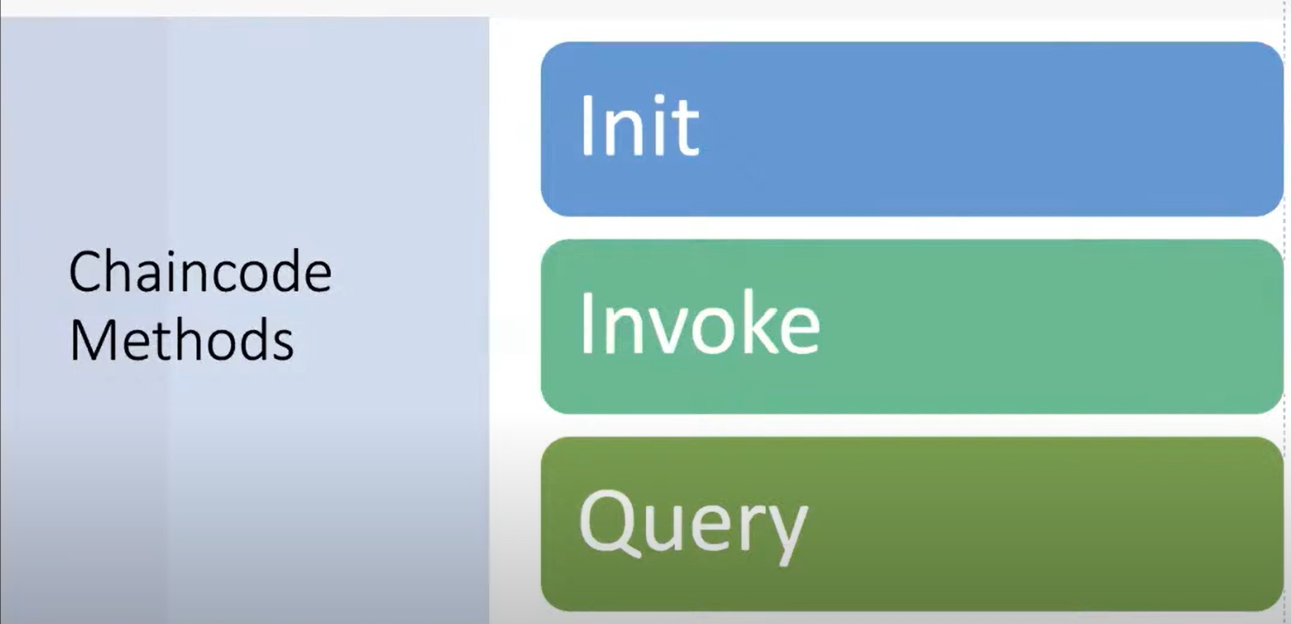

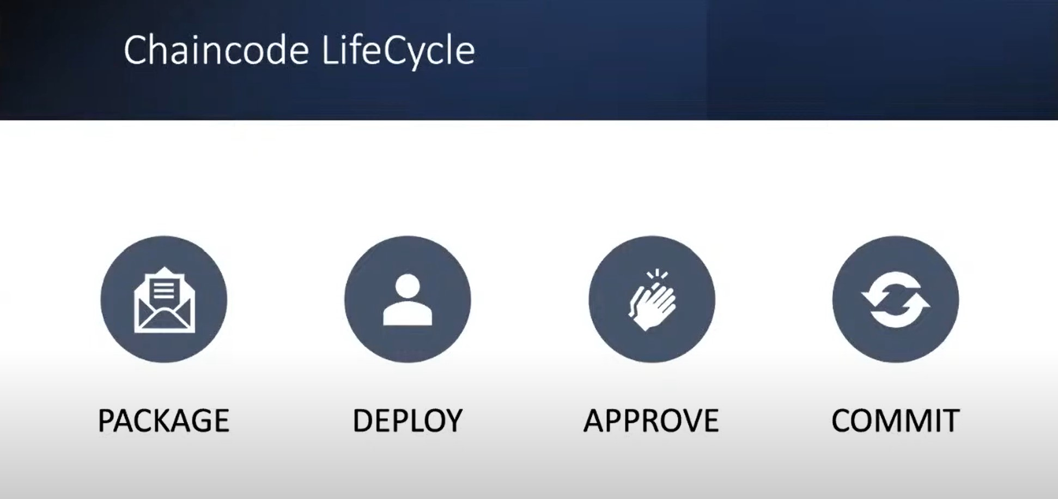

After the above deployment.

**Steps:**

1. Set the Org1 environment variables ( also provide the path).(inside bashrc.sh)
2. Invoke chaincode.

a.

# Environment variables for Org1

export CORE_PEER_TLS_ENABLED=true

export CORE_PEER_LOCALMSPID="Org1MSP"

export CORE_PEER_TLS_ROOTCERT_FILE=${PWD}/go/src/github.com/thesahilrai/fabric-samples/test-network/organizations/peerOrganizations/org1.example.com/peers/peer0.org1.example.com/tls/ca.crt

export CORE_PEER_MSPCONFIGPATH=${PWD}/go/src/github.com/thesahilrai/fabric-samples/test-network/organizations/peerOrganizations/org1.example.com/users/Admin@org1.example.com/msp

export CORE_PEER_ADDRESS=localhost:7051

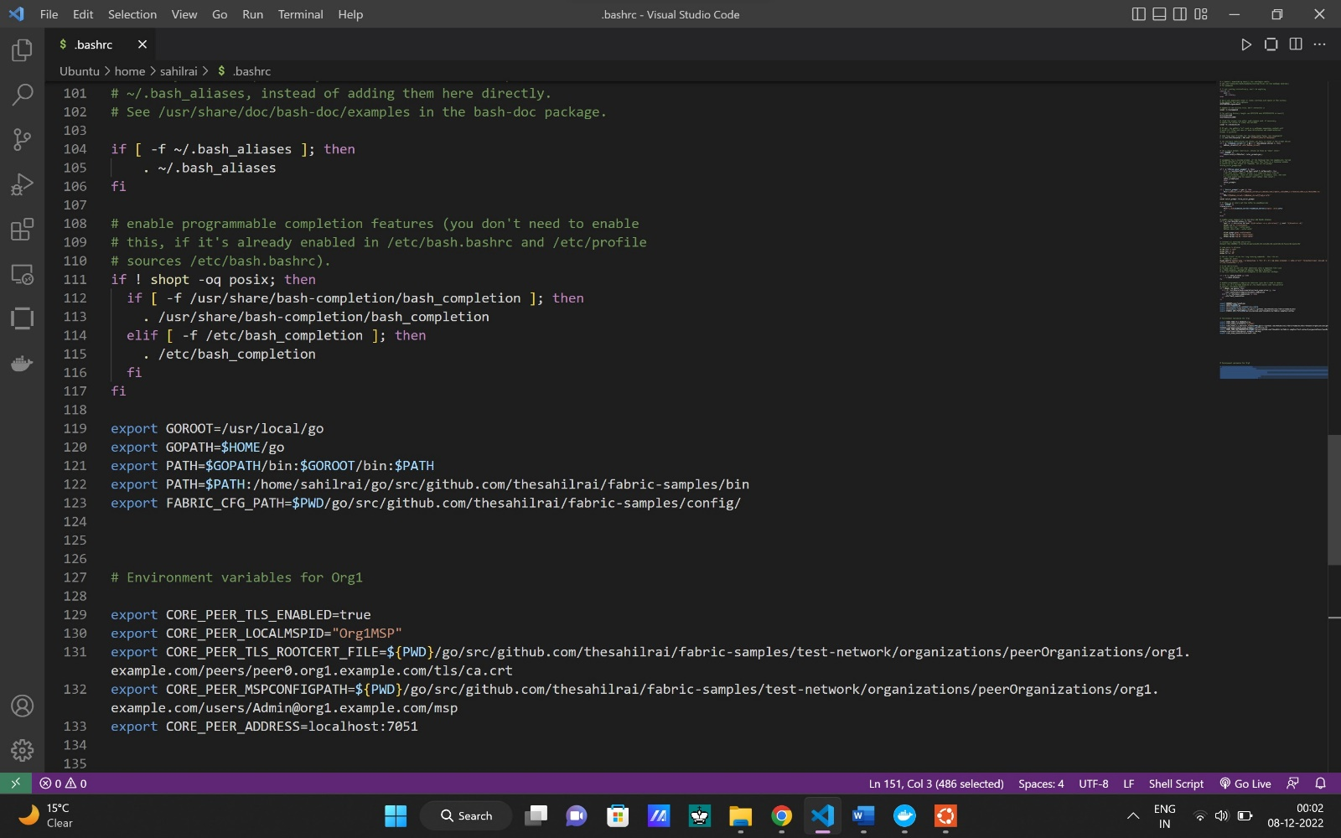

peer chaincode invoke -o localhost:7050 --ordererTLSHostnameOverride orderer.example.com --tls --cafile "/home/sahilrai/go/src/github.com/thesahilrai/fabric-samples/test-network/organizations/ordererOrganizations/example.com/orderers/orderer.example.com/msp/tlscacerts/tlsca.example.com-cert.pem" -C mychannel -n basic --peerAddresses localhost:7051 --tlsRootCertFiles "/home/sahilrai/go/src/github.com/thesahilrai/fabric-samples/test-network/organizations/peerOrganizations/org1.example.com/peers/peer0.org1.example.com/tls/ca.crt" --peerAddresses localhost:9051 --tlsRootCertFiles "/home/sahilrai/go/src/github.com/thesahilrai/fabric-samples/test-network/organizations/peerOrganizations/org2.example.com/peers/peer0.org2.example.com/tls/ca.crt" -c '{"function":"InitLedger","Args":[]}'

Run the above command. ( It will invoke chaincode on peers and orderer and also it initledger function is called).

(Also provide the path where the organization resides.)

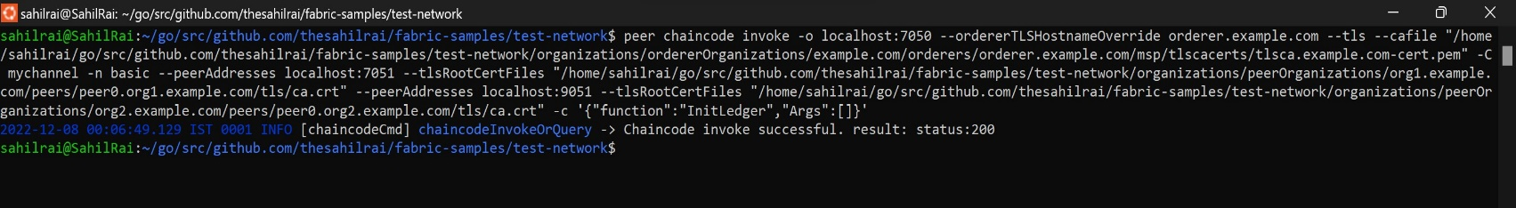

Now you can see the assets that are in chaincode.

1. GetAllAsset to see all the asset in chaincode (without passing argument).

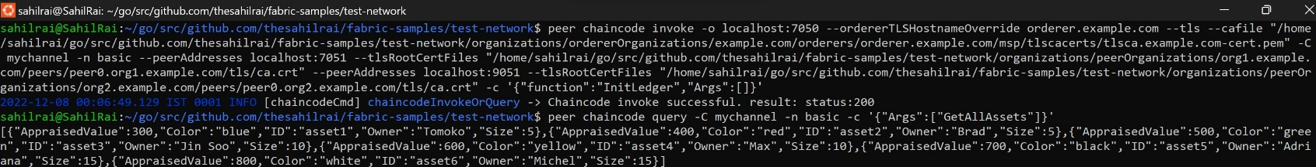

1. ReadAsset to see specific asset in chaincode (with passing argument ).



If you want to see the query of Org2 then set the env variable of Org2 and query the chaincode. (After setting env for Org2 then restart the ubuntu and run query, don’t network-down while restarting ubuntu).

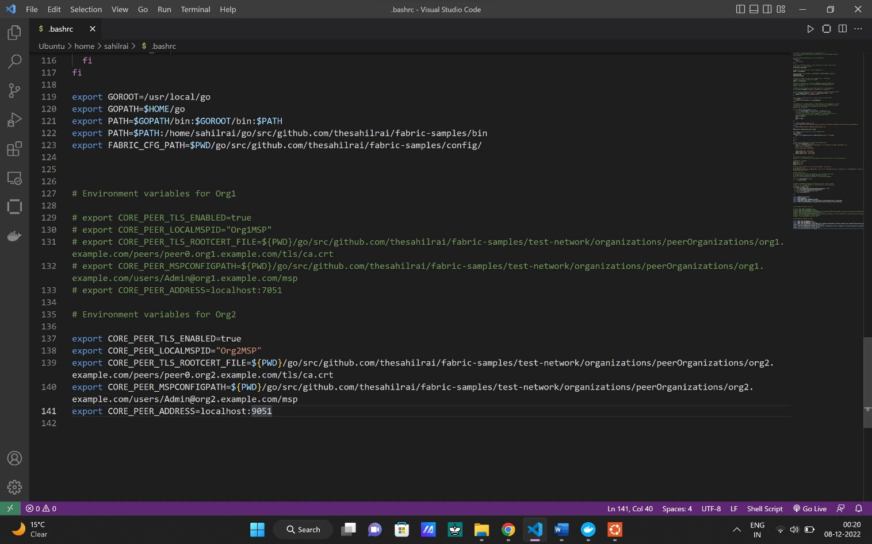

1. To interactively talk to container.
2. See the running container.

* docker ps -a

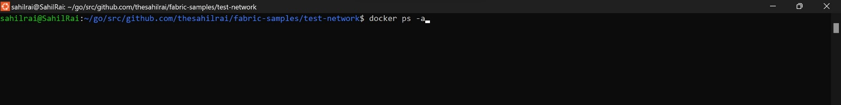

1. Select container ID or name.

* docker exec -it peer0.org2.example.com sh

To see the list of channel that peer joined.

* peer channel list

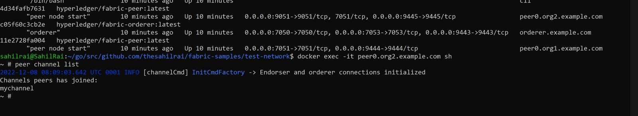

1. Now see the last block of that channel.

* peer channel getinfo -c mychannel

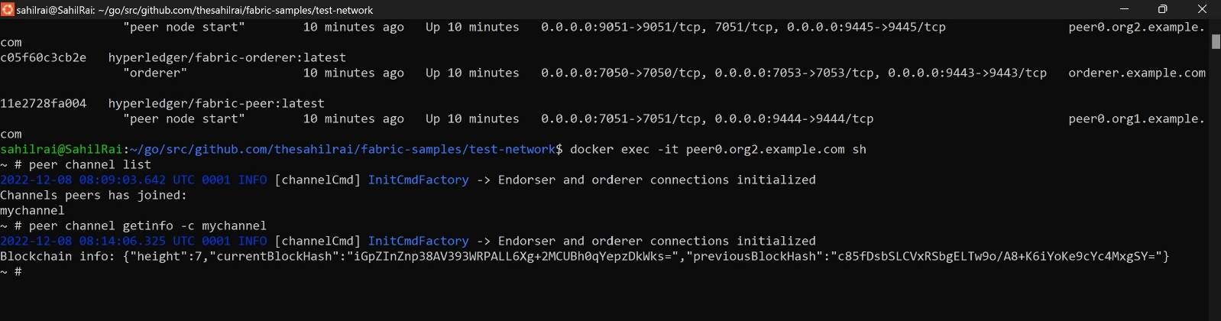

* exit

Height is 7 means the update, approve, commit and invoke all together makes block height.

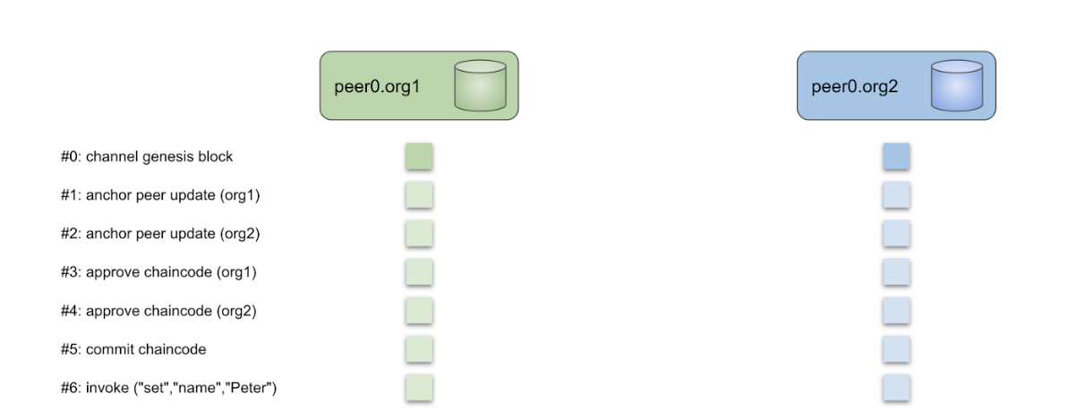

(**Note**: For both org1 and org2 the block is same you can check through above command.)

**Commercial paper :** Commercial paper is an unsecured form of promissory note that pays a fixed rate of interest. It is typically issued by large banks or corporations to cover short-term receivables and meet short-term financial obligations, such as funding for a new project.

There are four types of commercial paper: **promissory notes, drafts, checks, and certificates of deposit (CDs).**

**PaperNet :**

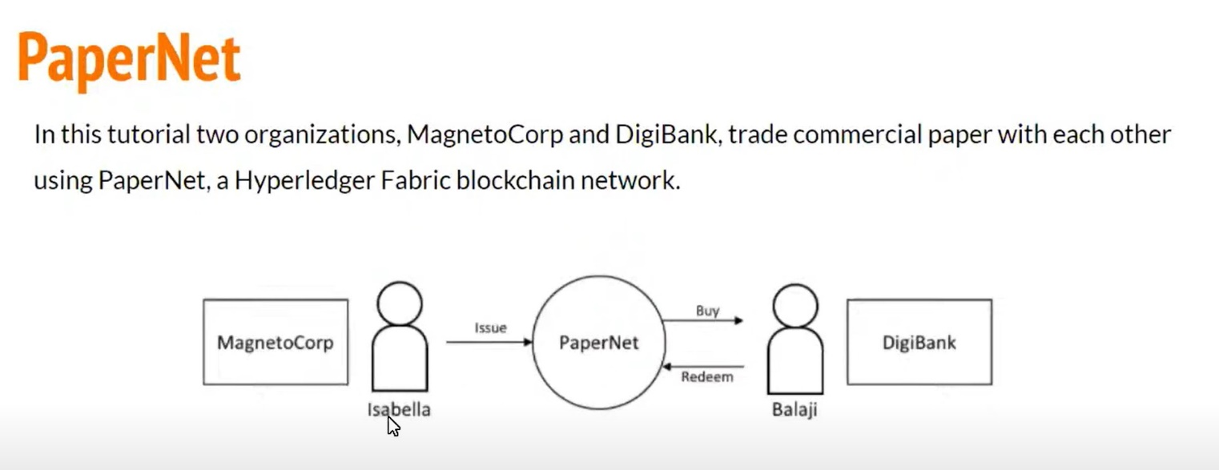

1. Here, we install and use commercial paper sample application and smart contract.
2. After set up test network, you will act as Isabella an employee of MagnetCorp who will issue Commercial Paper on its behalf.
3. Then switch to the role of Balaji an employee of DigiBank who will buy Commercial Paper and hold it for short period of time and redeem it with MagnetoCorp for a small profit.

Hyperledger Docs for Commercial Paper.

<https://hyperledger-fabric.readthedocs.io/en/release-2.2/tutorial/commercial_paper.html>

**Prerequisites :**

1. Install Nodejs

* curl -fsSL https://deb.nodesource.com/setup_16.x | sudo -E bash –
* sudo apt-get install -y nodejs

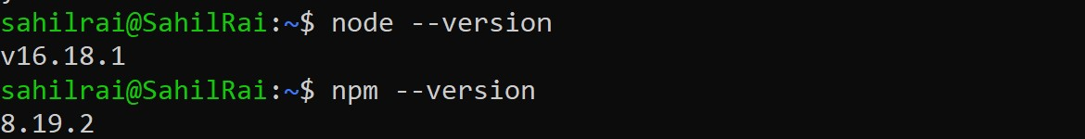

1. Go inside the commercial-paper.
2. cd $HOME/go/src/github.com/thesahilrai/fabric-samples/commercial-paper
3. Now start the network.
4. ./network-starter.sh

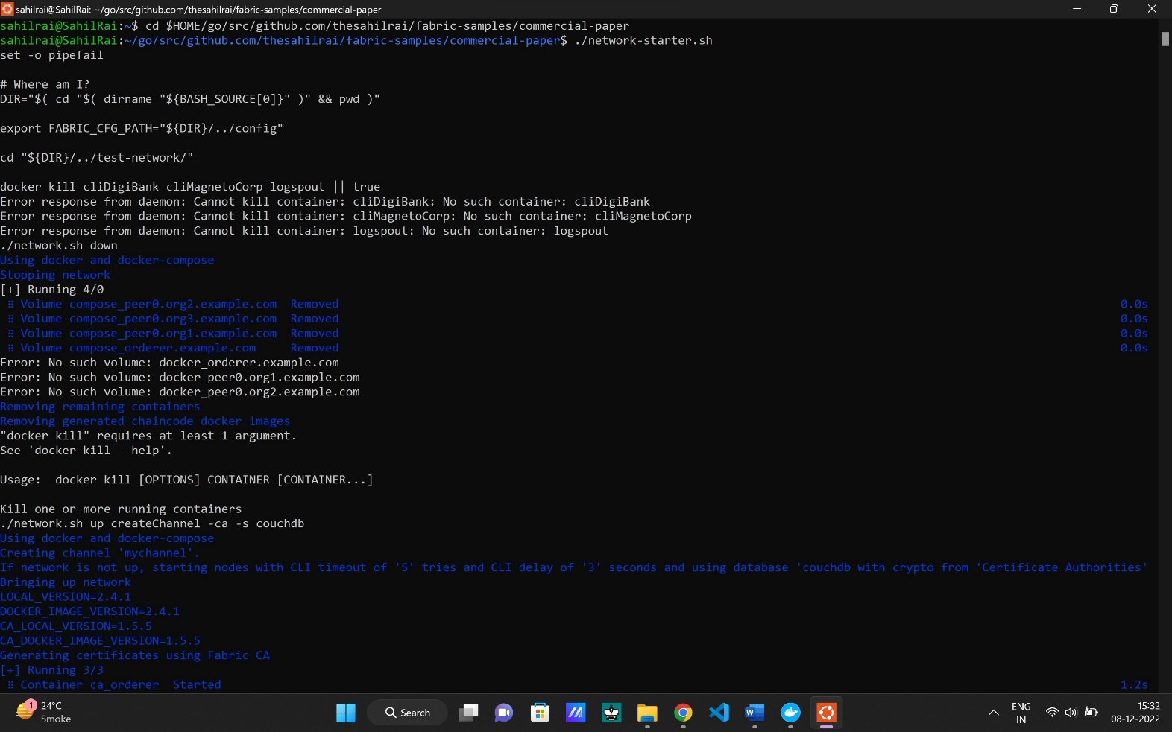

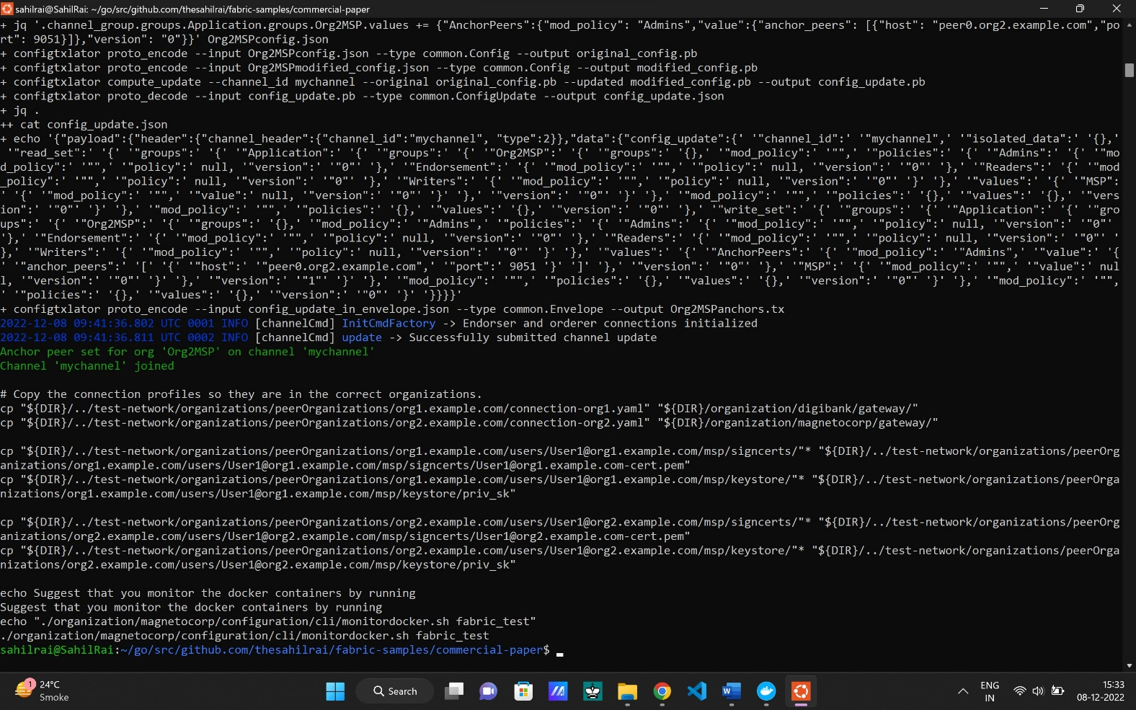

**Install and approve the smart contract as MagnetoCorp**

* cd organization/magnetocorp



* source magnetocorp.sh

(see the full list of environment variables printed in your window.)

* peer lifecycle chaincode package cp.tar.gz --lang node --path ./contract --label cp_0

(language is nodejs , cp is chaincode package) (this command create the package.)

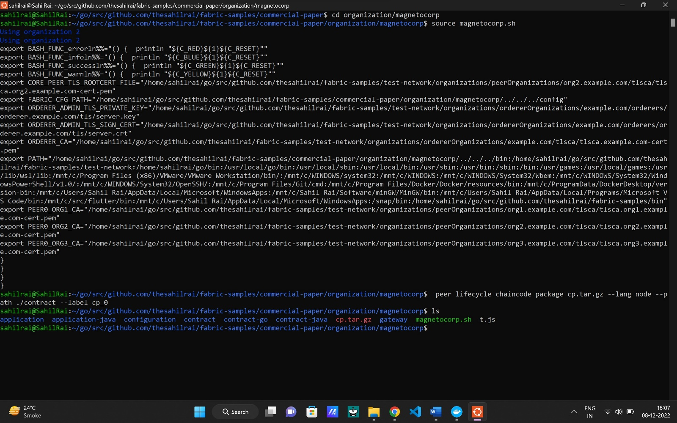

* peer lifecycle chaincode install cp.tar.gz

( The MagnetoCorp admin can now install the chaincode on the MagnetoCorp peer using this command. )

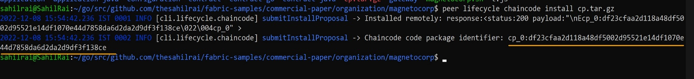

* Copy and save the chaincode package identifier ( use this later).

cp_0:df23cfaa2d118a48df5002d95521e14df1070e44d7858da6d2da2d9df3f138ce

(chaincode identifiers are used to referring that chaincode. For every updation in chaincode there is different identifier so through identifiers we can identify and see the updation in chaincode.)

If you lost the chaincode identifier the use below command to know chaincode identifier.

* peer lifecycle chaincode queryinstalled

We will save it as an environment variable.

* export PACKAGE_ID=cp_0:df23cfaa2d118a48df5002d95521e14df1070e44d7858da6d2da2d9df3f138ce

Here paste the cp_0 that you have saved.

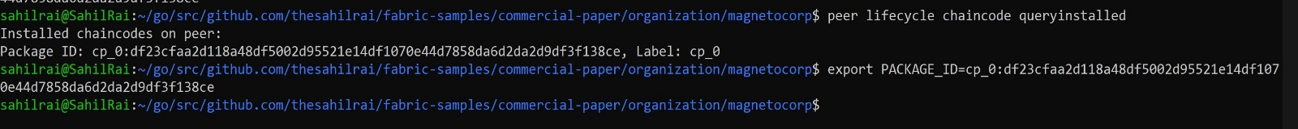

The admin can now approve the chaincode definition for MagnetoCorp using the below command.

* peer lifecycle chaincode approveformyorg --orderer localhost:7050 --ordererTLSHostnameOverride orderer.example.com --channelID mychannel --name papercontract -v 0 --package-id $PACKAGE_ID --sequence 1 --tls --cafile $ORDERER_CA

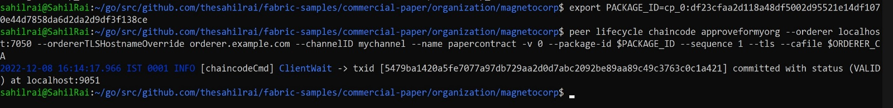

**Now,** open another ubuntu terminal (for DigiBank) and don’t quit the current terminal.

Do same as above for digibank.

* cd go/src/github.com/thesahilrai/fabric-samples/commercial-paper/organization/digibank
* source digibank.sh
* peer lifecycle chaincode package cp.tar.gz --lang node --path ./contract --label cp_0
* peer lifecycle chaincode install cp.tar.gz

save chaincode identifier. (use later as above)

cp_0:f2316bf21cdc9aa6c3650c815228f88b3ae20cd2a74f30a1db76f02be2c4d599

* peer lifecycle chaincode queryinstalled
* export PACKAGE_ID=cp_0:f2316bf21cdc9aa6c3650c815228f88b3ae20cd2a74f30a1db76f02be2c4d599
* peer lifecycle chaincode approveformyorg --orderer localhost:7050 --ordererTLSHostnameOverride orderer.example.com --channelID mychannel --name papercontract -v 0 --package-id $PACKAGE_ID --sequence 1 --tls --cafile $ORDERER_CA

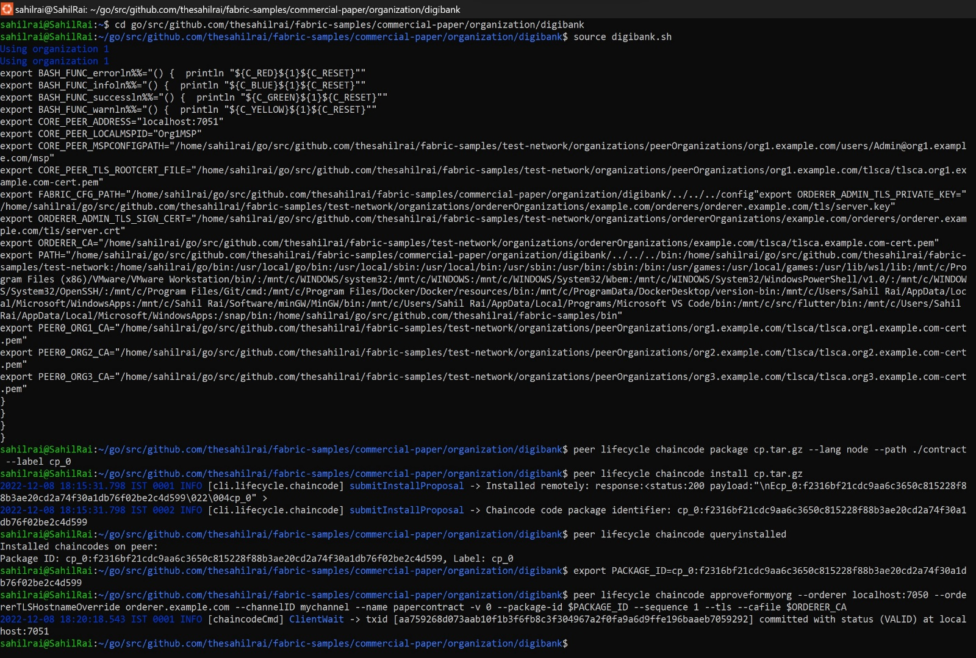

Now chanicode is approved by both (digibank and magnetocorp).

Here for both the org the orderer is same.

**Commit the chaincode definition to the channel:**

DigiBank and MagnetoCorp have both approved the papernet chaincode, we have the majority we need (2 out of 2) to commit the chaincode definition to the channel. Either organization can commit the chaincode to the channel, we will continue operating as the DigiBank admin.

And After commiting a new Docker chaincode container will be created to run papercontract on both PaperNet peers.

The DigiBank administrator uses the peer lifecycle chaincode commit command to commit the chaincode definition of papercontract to mychannel:

* peer lifecycle chaincode commit -o localhost:7050 --ordererTLSHostnameOverride orderer.example.com --peerAddresses localhost:7051 --tlsRootCertFiles ${PEER0_ORG1_CA} --peerAddresses localhost:9051 --tlsRootCertFiles ${PEER0_ORG2_CA} --channelID mychannel --name papercontract -v 0 --sequence 1 --tls --cafile $ORDERER_CA –waitForEvent

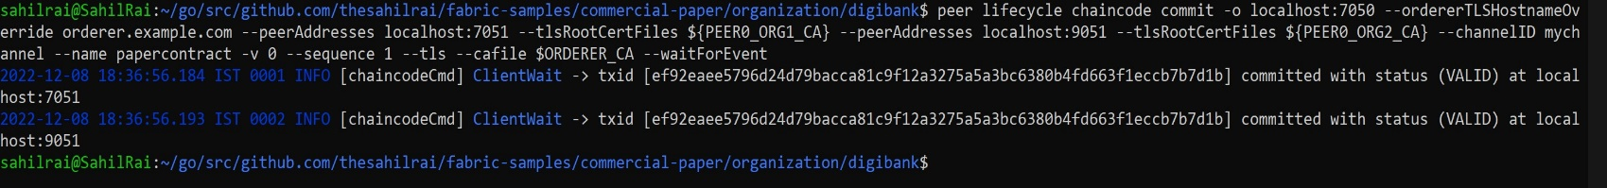

**Magnetocorp Application** :

1. Now go to application folder in magnetocorp.

* cd application

1. Now install the dependencies form package.json

* npm install

1. Enrollment of identity into Isabella wallet.

( Isabella can use the identity name and secret to generate the X.509 cryptographic material for the issue.js application. The process of using a CA to generate client side cryptographic material is referred to as enrollment. In a real world scenario, a network operator would provide the name and secret of a client identity that was registered with the CA to an application developer. The developer would then use the credentials to enroll their application and interact with the network. )

* node enrollUser.js

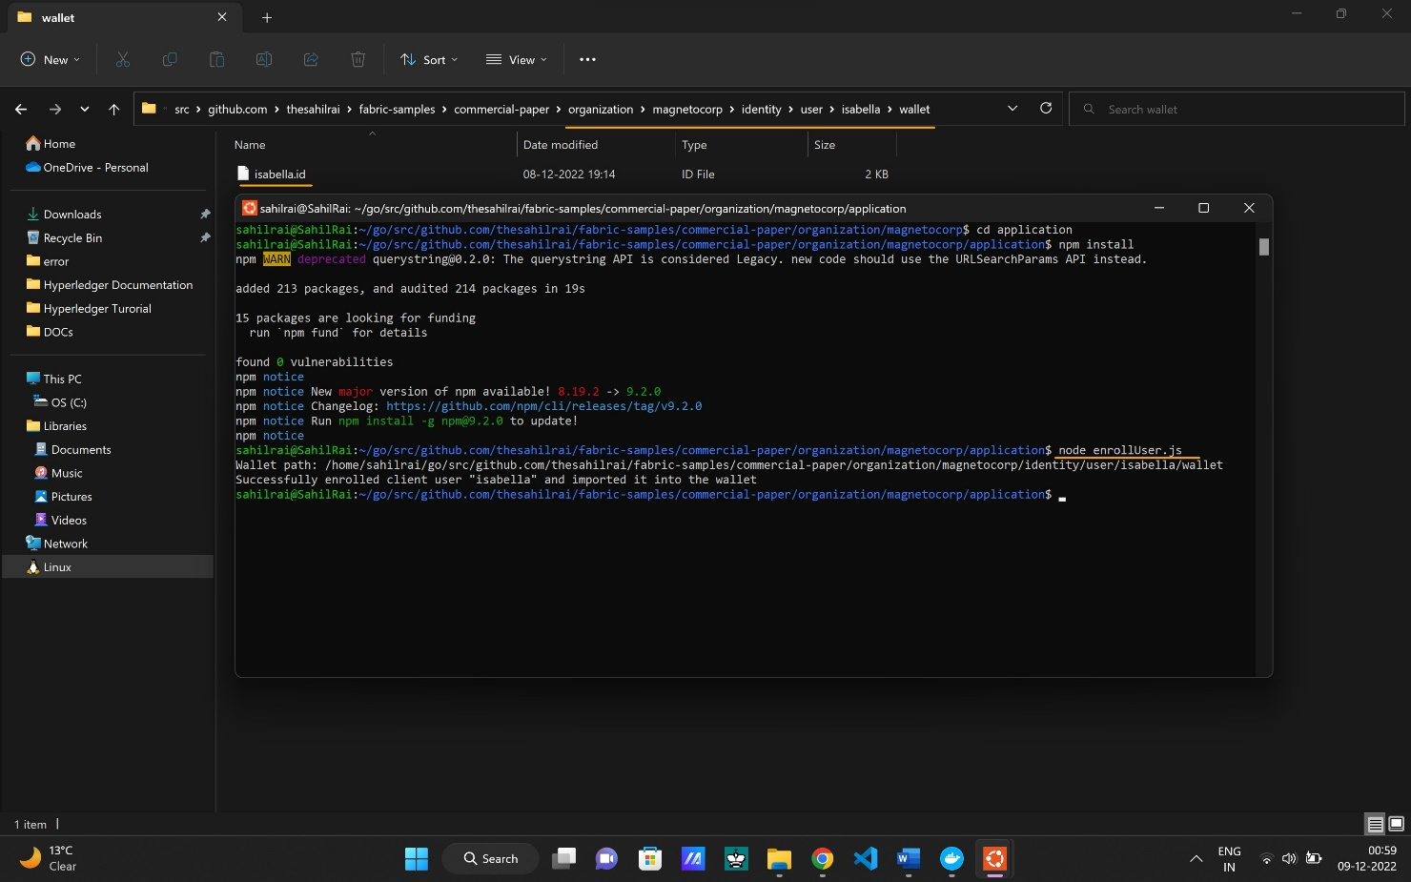

Isabella can store multiple identities in her wallet, though in our example, she only uses one. These Isabella.id include **privateKey** and **certificate**. PrivateKey is not distributed over network but a certificate can use. ( Isabella.id contain data in .json form)

1. Isabella can now use issue.js to submit a transaction that will issue MagnetoCorp commercial paper

* node issue.js

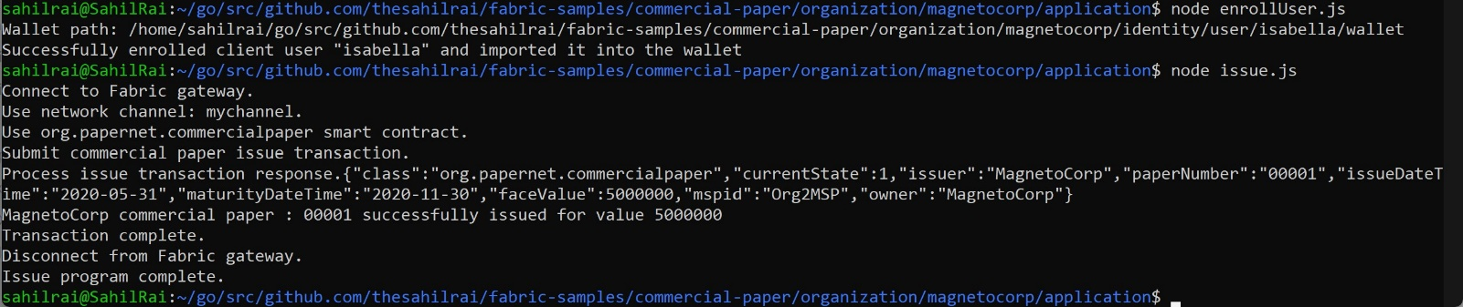

We can see from the program output that MagnetoCorp commercial paper 00001 was issued with a face value of 5M USD.

**Application DigiBank** :

Balaji uses DigiBank’s buy application to submit a transaction to the ledger which transfers ownership of commercial paper 00001 from MagnetoCorp to DigiBank. The CommercialPaper smart contract is the same as that used by MagnetoCorp’s application, however the transaction is different this time – it’s buy rather than issue. Let’s examine how DigiBank’s application works.

1. Go to application folder of digibank.

* cd application

1. Now install the dependencies form package.json

* npm install

1. Enrollment of identity into Balaji wallet.

* node enrollUser.js

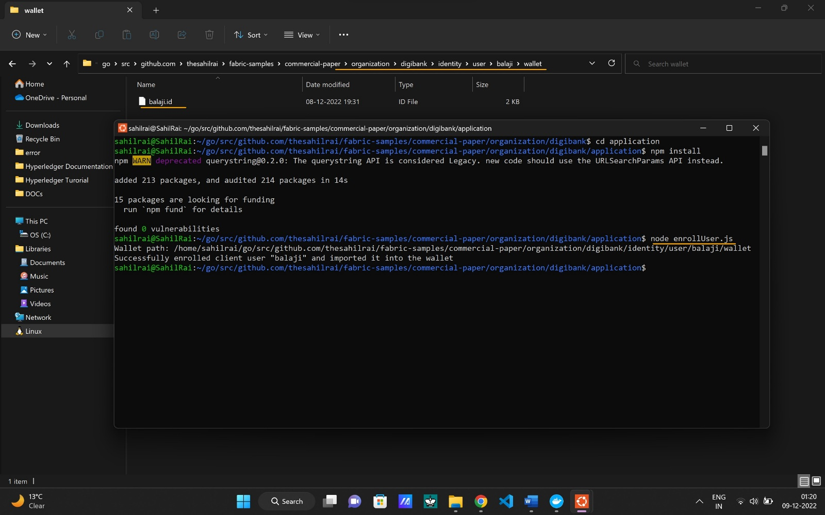

1. Balaji can now use buy.js to submit a transaction that will transfer ownership of MagnetoCorp commercial paper 00001 to DigiBank.

* node buy.js

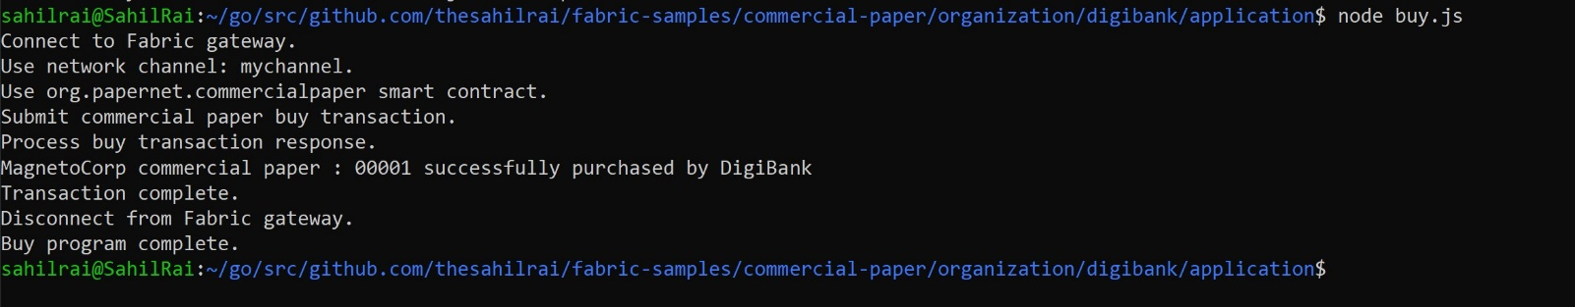

You can see the program output that MagnetoCorp commercial paper 00001 was successfully purchased by Balaji on behalf of DigiBank. buy.js invoked the buy transaction defined in the CommercialPaper smart contract which updated commercial paper 00001 within the world state using the putState() and getState() Fabric APIs. As you’ve seen, the application logic to buy and issue commercial paper is very similar, as is the smart contract logic. (You can see the buy.js code)

1. Run the redeem transaction in Balaji’s window.

* node redeem.js

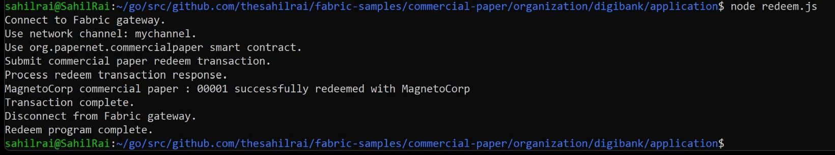

Again, it updated commercial paper 00001 within the world state to reflect that the ownership returned to MagnetoCorp, the issuer of the paper.

**Clean Up** :

1. Go to the root directory of the commercial paper.

* cd ..

1. Bring down the network.

* ./network-clean.sh

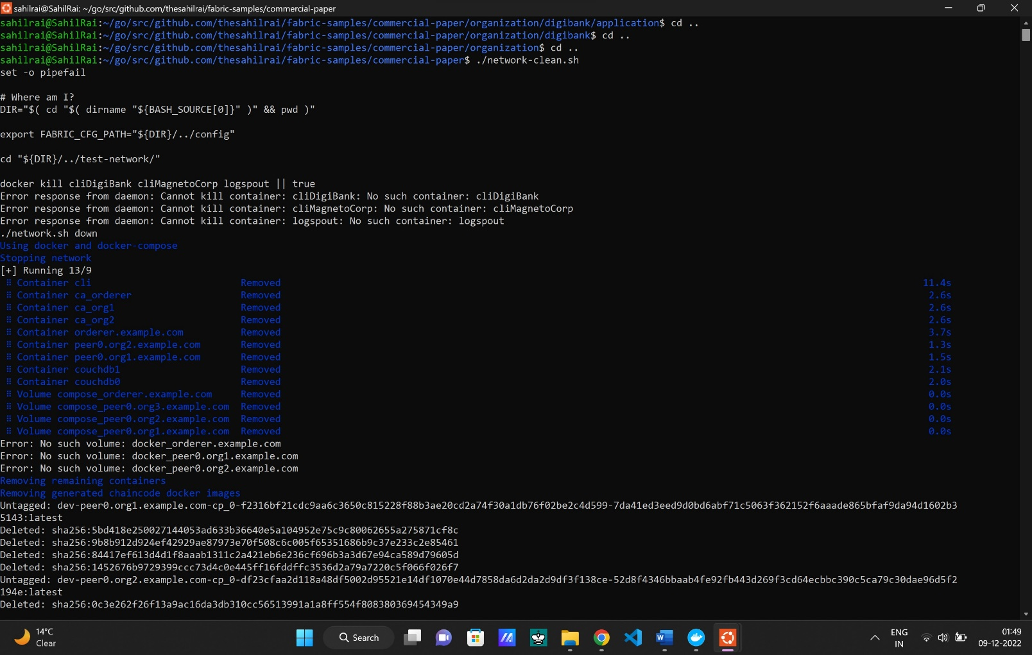

**Commercial Paper Example is over.**